# Using Triggers to Spawn Creatures in ScriptEase II

The goal of this tutorial is to introduce you to triggers in Neverwinter Nights. Triggers are used in most game engines to cause certain scripts to fire when the player walks into a specific area. You may have noticed them yourself in most popular video games.

We will make the triggers in Aurora, and then use ScriptEase II to spawn a skeleton into the game. The skeleton will drop a key that allows the player to unlock a treasure chest.

## Getting Started:

1. Back up your *.ses file and your module.
2. Make sure ScriptEase II is closed then start up the Aurora Toolset.

## Chests with Keys:

1. The captain has asked us to get some treasure from the cave, and we have unlocked a door using levers. However, if we played the game now, we would find no treasure and the game would end with disappointment. Let’s start by creating a key for the chest.
2. Select the Cave area. In the palette view, go to “Items” and create a new item as before by setting the filter to “Custom”, right clicking the “Plot Item” category, and clicking on “New”.
3. Set the “Item Type” to “Key” and the name to “Treasure Chest Key”. Set the category to “Plot Item”. Before closing the wizard, click on “Launch Item Properties” and change the tag of the item to “treasure_chest_key” in the dialog that pops up.
4. Now we need to add a treasure chest. Navigate to “Placeables” 🡪 “Standard” 🡪 “Containers & Switches” and Edit Copy one of the chests. The last one looks especially pirate-like.
5. Name the chest “Treasure Chest” with the tag “treasure_chest”.
6. Go to the “Lock” tab and set the chest to “Locked”. Click on “Key required to unlock or lock”. In the “Key Tag” field, write “treasure_chest_key”. The chest will now only open for creatures that have the Treasure Chest Key in their inventories.
7. Add the chest to the middle of the treasure room, behind the locked door, as in the screenshot.

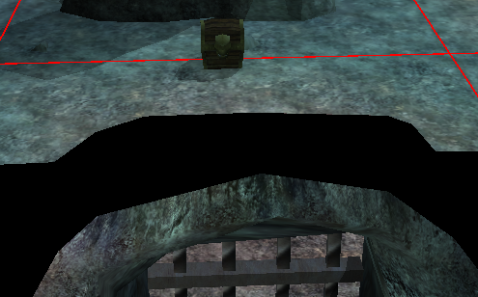

## Editing Creature Properties:

1. Edit Copy a Skeleton. Skeletons are found in the palette under “Creatures” 🡪 “Monsters” 🡪 “Undead” 🡪 “Skeleton”.
2. Name your Skeleton “Captain Talus” and give him the tag “captain_talus”.
3. In the “Statistics” tab, lower every setting as much as possible to make your skeleton very weak. We aren’t going to challenge the player’s combat skill in this story; our skeleton is only a plot device and so he will not present a challenge to the player. The “Total Hit Points” should be at 1 once you do this.
4. Click on the “Inventory …” button on the bottom left corner of the dialog. Find the Treasure Chest Key in the “Custom Items” tab under “Plot Item”. Double click on it to add it to the Skeleton’s inventory.
5. In the “Options” pane underneath the item selection pane, click on “Dropable” to make the skeleton drop the key when it is killed. Your skeleton’s inventory should look like the following screenshot.

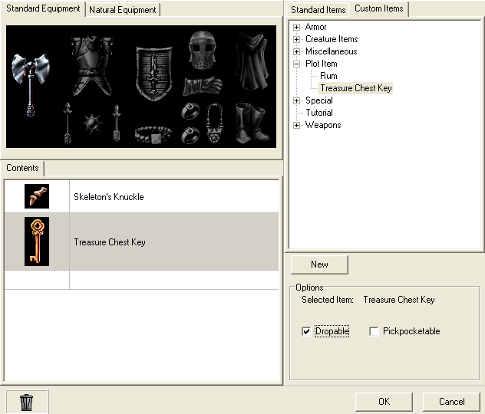

1. Click “Ok” on both dialogs to exit out of them.

## Creating a Trigger:

1. We are not going to add the Skeleton to the module like in previous tutorials. Instead, we are going to spawn it when the player walks near the chest. The player will then kill it and it will drop the key, which lets the player open the chest.
2.  To spawn a skeleton when we are near the chest, we need to draw a trigger around the chest. We create a trigger just like any other game object. In the palette view, navigate to “Triggers” 🡪 “Generic Trigger” and Edit Copy “New Generic”. Name it “Skeleton Spawn” and give it the tag “skeleton_spawn”.
3. Paint a square trigger around the chest as shown by clicking in the top right corner, then the top left, bottom left, bottom right, then double clicking the top right again.

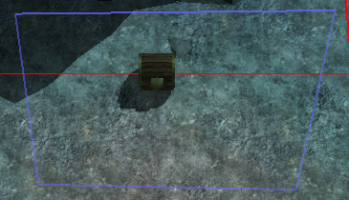

## Creating a Waypoint:

1. We need a place for the skeleton to spawn. We do not want it to spawn on top of the chest, and the trigger is too ambiguous to spawn on. Neverwinter Nights provides a type of object called a “Waypoint” that can be used to provide a reference for other objects on where to go.

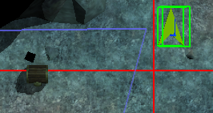

1. Edit copy the “Waypoint” object found in the palette under “Waypoints” 🡪 “Waypoint”. Call it “Skeleton Spawn Point” and give it the tag “skeleton_spawn_point”. Place it above the top right corner of the trigger. The orientation of the waypoint does not matter.



## Editing Conversations:

1. While we’re in Aurora, let’s edit the Captain’s conversation so that he can respond to the player finding some treasure. We want to add more conversation nodes to match the following screenshot.

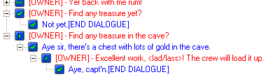

1. Save your module in Aurora. Close Aurora and open ScriptEase II.

## Scripting Triggers in ScriptEase II:

Tip:To filter story components by type, click on the “All Types” button to select which ones should be visible. Components that have a slot with one of the types selected will be shown.

1. Scripting triggers is as easy as scripting anything else. Create a new Story Point after the “Lever 3 Activated” Story Point called “Treasure Approached”. Find the cause titled “When (T) subject is entered by Entering Creature” with a Trigger object as the type and drag it into the Story Point. To filter story components by types, click on the “All Types” button and choose only the “Trigger” type. There is a Deselect All button that may be useful for this.
2. Drag the Skeleton Spawn trigger into the subject slot.

Tip:Captain Talus has a game object associated with it even though it does not exist in any area. This is why we created a blueprint.

1. Spawning the skeleton is also a simple effect. Find the “Create a new Object at Location” effect and drag it into the Yes section. Drag Captain Talus into the Object slot.
2. You will notice that the effect is asking for a “Location” object. Just like Questions, these are created by descriptions. The description we need is called “Location describes the location of Object”. Drag this description above your effect and drag the “Skeleton Spawn Point” into its Object slot.
3. Drag the Location object created by the description into the Location slot of the effect.
4. We also want to succeed the Story Point now, or else a skeleton will spawn every time we enter the trigger. Drag the “Succeed Current Story Point” effect after the other effects and drag the “Treasure Approached” Story Point object into its slot.
5. We also need to update our **Treasure Island** Journal with a Journal Point that tells the player that the skeleton appeared (Figure 1).

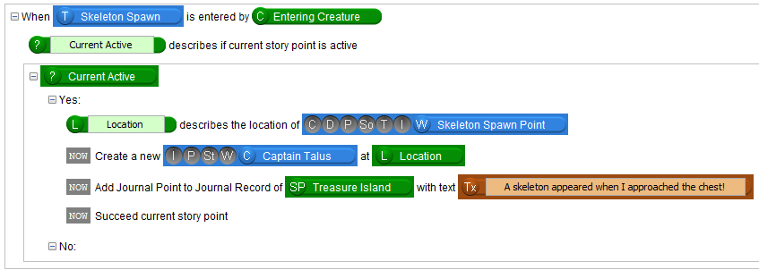

Figure

1. Now would be a good time to test your story.

## Scripting the Treasure Chest:

1. The player will kill the skeleton and retrieve a key from its corpse. The player then uses the key to open the treasure chest. This is all done automatically by the game engine, so we don’t need to worry about scripting this. What we do need to script is what happens when we open the chest.
2. Create a new Story Point after the previous one called “Treasure Chest Opened”. This will be a very simple story point used to progress the story.
3. Select the new Story Point. Find the cause “When subject is opened by Last Opener” and drag it into this Story Point. Drag the Treasure Chest object into the subject slot.
4. Drag a “Show text above the PC” effect into the Yes section and set the text to “There is a lot of gold in this chest!” This effect makes it look like the player character is saying something.
5. Drag a “Disable dialogue line” effect into the story block and drag in the “Find any treasure yet?” line.
6. Add a Journal Point to let the player know that they should head back to the Captain and add the effect to succeed the Story Point (Figure 2).

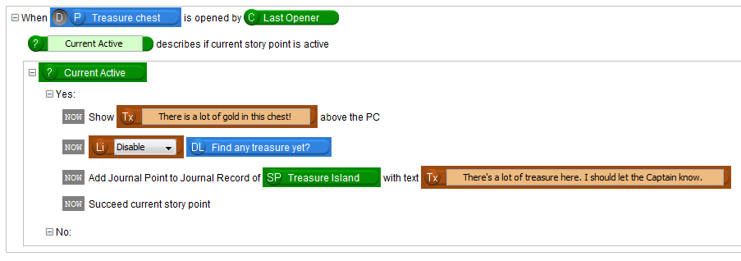

Figure

## Finishing the Story:

1. Let’s finish up this storyline by adding one more story point. Name it “Returned to the Captain”. Select this new Story Point. Drag in a “When subject is reached” cause and drag in the “Aye, Capt’n” line we created earlier.
2. Drag in a “Disable dialogue line” effect into the Yes section and drag the “Find any treasure in the cave?” line into its slot.
3. Succeed the Story Point so that the Story Point matches the following screenshot (Figure 3).

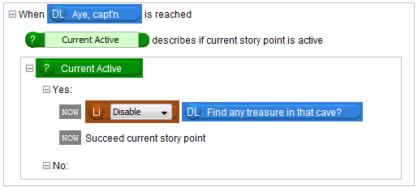

Figure

1. Our story is not completely finished, but the main quest is. We will be adding more conversation nodes to the Captain’s conversation. But that’s for the next tutorial!

Theoretically, the skeleton could open the treasure chest if he were so inclined since he has the key. If you want to expand on this tutorial you could ensure that the chest only opens for the player character.

We now know how to use triggers. We also used some build in functionality of the game engine to progress the story without the need for scripts, which saves us from having to check if anything works.

In the next tutorials, we will be going over some advanced features of the story system.